S.Y. B.Tech. (ECE)
Trimester: V Subject: Power Devices & Machines
Name: Shreerang Mhatre Class: TY
Roll No: 52 Batch: A3

Experiment No: 06
Name of the Experiment: Variable frequency drive (VFD) for three phase induction motor
Performed on: 23/11/2023
Marks
Teacher’s Signature with date
Submitted on: 23/11/2023

Aim: To study the operation of a variable frequency drive (VFD) for three phase induction motor.
Pre-requisite: Knowledge of power semiconductor devices and variable voltage variable frequency induction motor operation.
Objectives: To understand the constant V/F control technique to achieve full motor torque from very low speeds right upto rated speed with controlled motor current so as to eliminate starting current inrush.
Components and Equipment required:
Sr. No. | Equipment / Instruments | Range/Specification
 | Amtech Electronics VT 230S 07HA three-phase variable frequency drive (VFD) for induction motor | 415 V, 50 Hz, 1HP
 | Kirloskar Electric three-phase squirrel cage induction motor | 415 V, 50 Hz, 0.75 KW/1 HP, 1380 rpm
 | Mark Electrics separately excited DC generator coupled to induction motor | 0.75 KW/1 HP, 1500 rpm, 230 V armature, 230 V field
 | Advani Oerlikon shaft-mounted DC tachogenerator | 200 V/70 mA @ 4000 rpm
 | Automatic Electric three-phase variac for supply voltage variation | 415 V, 15 A, 50 Hz
 | Single-phase bridge rectifier for field circuit of DC generator | 230 V, 50 Hz
 | Lamp bank for loading DC generator
 | Non-contact digital tachometer
 | Automatic Electric moving iron AC ammeter | 5 A
 | Automatic Electric moving iron AC voltmeter | 600 V

Theory:

For an induction motor working under constant V/f control with low values of slip frequency, the torque vs speed and current vs speed characteristics can be approximated by:
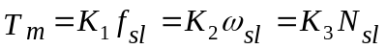
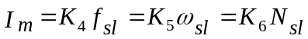 (1)
(2)
where
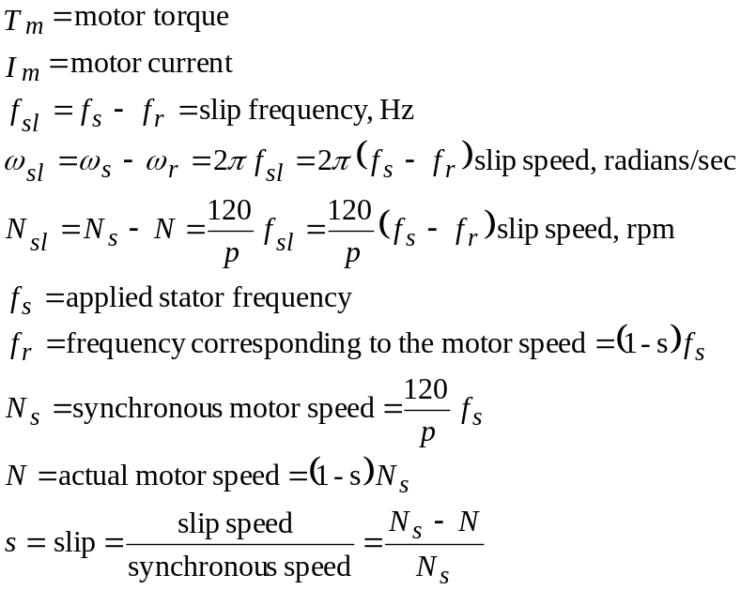

Hence the speed-torque characteristic is:

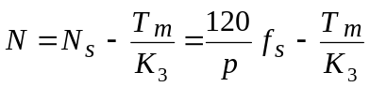
(3)

Description of the variable frequency drive:

1. Power circuit: The power circuit shown in Fig. 1 consists of a three-phase full-bridge IGBT inverter which generates a balanced three-phase variable voltage variable frequency AC supply for the three-phase induction motor. The DC supply to this bridge is obtained by rectifying and filtering the three-phase mains supply using a three-phase diode bridge rectifier followed by a capacitor filter.

The induction motor is mechanically coupled to a separately excited DC generator whose armature A-AA is connected to a load (lamp) bank. Varying the number of ON lamps varies the electrical load on the DC generator which in turn varies the mechanical load on the motor.

The field supply F-FF to the generator is obtained by rectifying the single-phase AC mains supply by a full-wave rectifier. As the inductance of the field winding of the DC generator is large, no separate filter inductance is required for filtering the field current.

2. Control circuit: A microprocessor-based control circuit using a sinusoidal PWM control technique provides the gate drive signals to the IGBT switches via isolated driver circuits. The switching (carrier) frequency is 4 KHz (nominal).

The control circuit of this drive does not use speed feedback. Hence speed regulation due to load changes is achieved by employing slip compensation which increases the inverter output (stator) frequency as the load torque increases so that the actual motor speed remains nearly constant.

At low frequencies, equations (1) to (3) do not apply as the underlying assumption that the applied voltage is nearly equal to the motor back emf is no longer true as the stator impedance voltage drop becomes a significant fraction of the applied voltage. Hence voltage boost is applied at low frequencies, with the amount of boost determined by the motor current which is roughly proportional to the load torque.

Fig. 14-19¹ shows the schematic and waveforms for a PWM-VSI (Voltage Source Inverter) while Fig. 14-20¹ shows the block diagram for electromagnetic braking in this inverter. Fig. 14-21¹ shows the block diagram of an induction motor speed control circuit in which the motor speed is not measured.

These drives can either be controlled from a remote computer or locally via the front cover-mounted operation panel.

3. VFD front panel: The front operating panel can be divided into three sections. The first (upper) section consists of a five digit seven segment LED display as well as polarity, status and units indication LEDs. The second (middle) section comprises of the parameter operation knob, while the third (bottom) section consists of operation, parameter operation and mode selection keys.

The drive parameters can be set as well as monitored from the operation panel by appropriately selecting one of the four control modes viz. Monitor Mode, Block A Parameter Mode, Block B Parameter Mode, Block C Parameter Mode (Utility Mode is reserved for future use).

In the Monitor Mode, the drive parameters such as inverter output frequency, inverter frequency setting, motor current and voltage are displayed by accessing different sub-modes. Drive parameters cannot be changed in this mode.

In the Block A Parameter Mode, frequently changed drive parameters such as inverter frequency setting, acceleration/deceleration times, torque boost can be set.

In the Block A & Block B Parameter Modes, infrequently changed drive parameters such as motor rating, overcurrent limit, DC braking, control methods and PID controller settings can be set.

PROCEDURE:

1. Switch-on the drive by pressing the ‘ON’ pushbutton of the three-phase DOL (direct-on-line) starter. Adjust the supply voltage to 390V by means of the three-phase variac.

2. At power-on, the drive enters the Monitor Mode and the display shows ‘OFF’. The LCL and Hz LEDs will also light.

3. Press the FWD key. The motor will start rotating in the forward direction and accelerate to its final speed in the preset acceleration ramp time (default value is 10sec). The display, still in the Monitor Mode, will show the previously set output frequency (default value is 10Hz) and FWD LED will light.

4. Press the STOP key. The motor will slowly decelerate to a halt in the preset deceleration ramp time (default value is 20sec) and the display will decrease to ‘0.00’. The FWD LED will flicker while DC dynamic braking is applied.

5. Press the REV key. The motor will now start rotating in the reverse direction and accelerate to its final speed in the preset acceleration ramp time. The display, still in the Monitor Mode, will show the previously set output frequency and REV LED will light.

6. Press the STOP key. The motor will slowly decelerate to a halt in the preset deceleration ramp time. The REW LED will flicker while DC dynamic braking is applied.

7. To change the motor speed, the drive output frequency has to be changed. For this, press the RST/MOD key once. The display enters the Block A Parameter Mode and the display will alternate between ‘A00-0’ and the previously set output frequency. Now press the SET key once. The display will show the previously set output frequency and the last digit will flicker. The digit to change can be selected by repeatedly pressing the LCL/← key. The frequency can now be incremented or decremented with the parameter operation knob and the motor will slowly accelerate or decelerate accordingly. To set the selected frequency, press the SET key. Repeatedly pressing the RST/MOD key will now cycle the display through the Block B Parameter Mode, Block C Parameter Mode, Utility Mode and back to Monitor Mode.

8. Measure the N/f (motor speed vs output frequency) characteristics, for different drive output frequencies for forward direction.

Observations:

1. N/f characteristics at rated supply voltage (415 V) and on no-load

Sr.  No. | f  Hz | Forward Direction | Reverse Direction
Sr.  No. | f  Hz | N  rpm | N  rpm
1 | 50
2 | 45
3 | 40
4 | 35
5 | 30
6 | 25
7 | 20
8 | 15
9 | 10
10 | 5

Graphs and calculations

1. N/f

1.1 Plot the motor speed (N rpm) vs output frequency (f Hz) curve

CONCLUSIONS:
References:

- N. Mohan, T.M. Undeland & W.P. Robbins, Power Electronics: Converters, Applications & Design, Third Edition, John Wiley & Sons, 2002.

